2025 TERM 1 MZIMBA NORTH DISTRICT EXAMINATIONS
AGRICULTURE FORM 4

Thursday, 18 December
Time allowed: 1 hour 30 min Sessions
8 am onwards
PAPER II
PRACTICAL
(40 marks)
INSTRUCTIONS
- This paper contains 7 printed pages. Please check.
- This paper has two sections: A and B
- Answer all questions in the spaces provided
- Write your name on all pages in the spaces provided

©MZN-T1-2025

SECTION A (20 marks)
- The table below shows results of an experiment on milk production upon feeding a dairy cow using different amounts of concentrates

Amount of concentrates (kg) | Amount of milk produced ()
4 | 10
8 | 30
12 | 50
14 | 60
20 | 80
24 | 80

- Using a graph paper provided on page 2, plot a graph of amount of milk produced against amount of concentrates. (4 marks)

- Use the graph to estimate the following;
- Amount of milk produced if 10 kg of concentrates was used to feed the animal.
____________________________________________________ (1 mark)
- Amount of feed used to produce 20 litres of milk. ___________________________________________________ (1 mark)
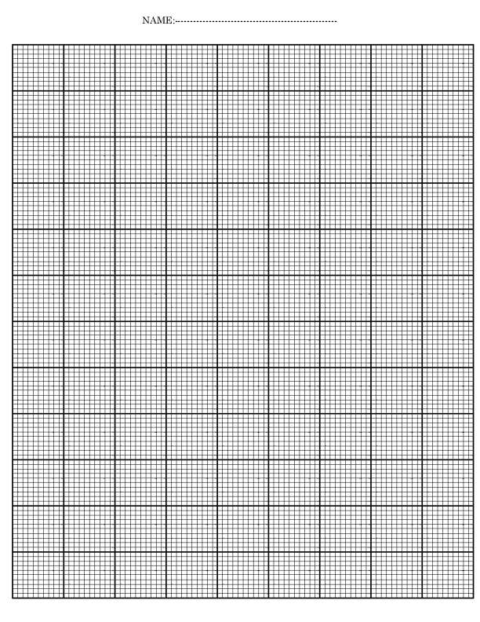
- Identify the recommended amount of feed for high milk production.
__________________________________________________________ (1 mark)
- Give a reason for the answer in (c) above
__________________________________________________________________
(2 marks)

- State the economic principle being demonstrate by the graph.
__________________________________________________________________
- mark)
- An agriculture teacher brought the following materials to a Form 3 class:
- 3 Filter paper
- 3 Funnels
- 3 Measuring cylinders (250 ml)
- Water
- 3 soil samples: sand, clay and loam
Using the materials provided, describe an experiment to determine water holding capacity of different classes of soil. In your description, include procedure, observation, results and conclusion
________________________________________________________________________________________________________________________________________________________________________________________________________________________________________________________________________________________________________________________________________________________________________________________________________________________________________________________________________________________________________________________________________________________________________________________________________________________________________________________________________________________________________________________________________________________________________________________________________________________________________________________________________________________________________________________________________________________________________________________________________________________________________________________________________________________________________________________________________________________________________________________________________________________________________________________________________________________________
(10 marks)

- You are provided with the following specimens labelled P, Q and R.
- Which example of roughages is specimen Q?
__________________________________________________________________
(1 mark)
- Give any two examples of livestock that feed on specimen Q
- ____________________________________________________________
- ____________________________________________________________
(2 marks)
- State any two advantages of specimen P over Q as animal feed.
- ________________________________________________________________________________________________________________________
- ________________________________________________________________________________________________________________________
(2 marks)
- Mention any two exotic breeds of goats that are kept for production of specimen R
- ____________________________________________________________
- ____________________________________________________________
(2 marks)
- Name one disease that can lower the quality of the animal product R
__________________________________________________________________
(1 mark)
- State two ways of controlling the disease mentioned in (e) above
__________________________________________________________________
(2 marks)
- You are provided with the following specimen labelled X, Y and Z.
- What type of plant propagation is used to grow specimen X
__________________________________________________________________
(1 mark)
- State any one limitations of using specimen X as a planting material
- ___________________________________________________________
(1 mark)
- Explain any one way in which growing specimen X mitigate effects of climate change.
____________________________________________________________________________________________________________________________________(2 marks)
- What form of soil degradation is caused by excessive use of specimen Z in crop production
__________________________________________________________________
(1 mark)
- Mention the cropping system that relies on use of natural practices such as application of specimen Y.
(1 mark)
- Explain any two advantages of the cropping system mentioned in (e) above
________________________________________________________________________________________________________________________________________________________________________________________________________________________________________________________________________
(4 marks)

END OF QUESTION PAPER

